The Player

# GameObject Structure

The Player GO contains a few elements as shown in the picture:

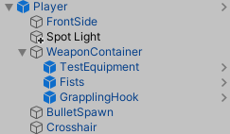

The main **Player** GO has a rigidbody and two colliders: one used for collision with the environment and the other to check if the player is grounded. It also contains all the scripts that define the player’s behavior. There is also a distance joint which is used for swinging.

**FrontSide** is used for graphics and sound effects, thus it has a sprite renderer, an animation controller and an audio source. State Sound Data scripts have to be added for each player state that makes a sound.[1]

**WeaponContainer** is a container for all equippable items (weapons). Children objects will be automatically added to the inventory on start.

**BulletSpawn** is a placeholder positioned where the bullets will be spawned.

**Crosshair** is game object that helps with aiming when a ranged weapon is equipped. The bullet is spawned at BulletSpawn and travels in the crosshair’s direction. It has the CrosshairMovement script where the designer can tweak the crosshair’s movement speed and its maximum allowed angle.

# Ledge Grabbing

Ledge grabbing works by shooting two raycasts while the player isn’t grounded. If one of the raycasts hits a wall and the other doesn’t hit anything, a ledge is detected. Many parameters are exposed to tweak the values for best ledge grabbing and climbing:

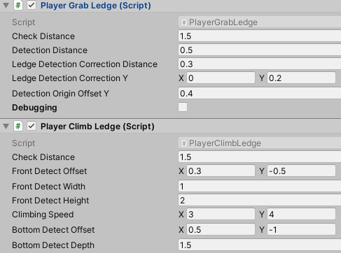

To better see what each parameter does, check the debugging option and show gizmos in the game view.

1. Note: At the moment, the scripts accept either standard audio clips or FMOD events as we did a transition to FMOD but we haven’t got much audio in that format yet.